Instruction:

Complete all questions in 1 hr.

Let’s get started with nice and easy examples of Batch script:

1. Open your favorite text editor. Save it as filename.bat (All files) right click on the file and

edit> type >

@echo off

echo Hello World!

pause

Run it. You have created your first batch file.

*Write the function of set up commands @Echo off and pause.*

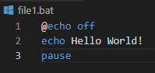

1. Create a batch program which takes two numeric inputs from the user and checks whether they are equal or not.

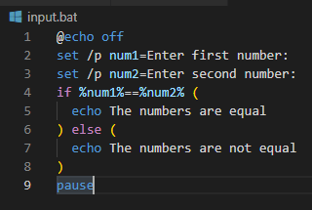

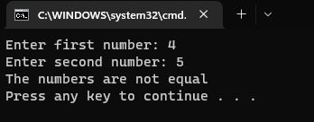

1. Create a batch program which takes a numeric input from the user and checks whether the input is odd or even.

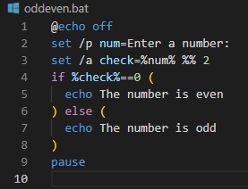

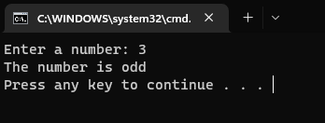

1. Create a batch program which prints natural numbers 1 to 10 using for loop.

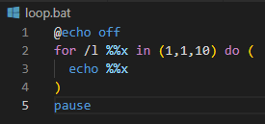

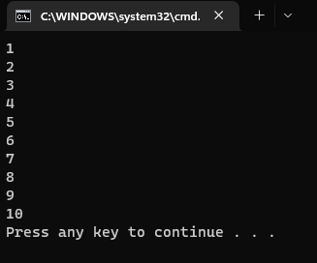

1. Create a simple calculator using a batch script. Which takes two number and third inputs can be “add” ,“sub”, “mul”, “div” and displays the result after calculation and displays error message for any other input in the third. eg: if first input is 2 , second input is 3 and third input is add then it displays the result 5. Note: use function

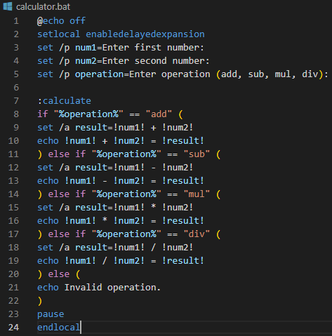

1. Write a batch program to swap mouse keys.

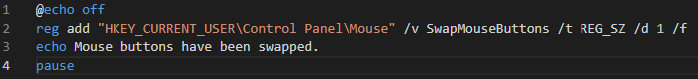

1. The following script is the malicious script responsible for system crash. Explain how it works and explain how you can protect your pc from system crash in Windows OS and Linux.

It is not permanently harmful for computers but annoying.

**Warning: do not run this script.**

**:S**

**Start %0**

**Goto S**

The script is a straightforward infinite loop that repeatedly recreates itself and directs execution to the start of the script, causing the script to run without end. This activity will use up all of the CPU and RAM that are available, which could slow down the system and ultimately lead to a crash. To protect your Windows PC from this type of script, you can use a software that detects and blocks infinite loops. Additionally, you can use the task manager or an activity monitor to close the script if it is running and consuming too many resources.

To protect our Linux PC from this type of script, we can use a software that detects and blocks infinite loops or use the command-line tool 'top' to monitor the processes running on your system. If we notice a process that is consuming too many resources, we can use the command 'kill' to terminate it. Additionally, we can use the command 'ulimit' to set a limit on the amount of resources that a script can use, which can prevent a script from consuming too many resources and crashing the system.

It is important to note that the script will not cause permanent harm to your computer. However, it is still a malicious script that should not be run on any computer. It is crucial to practice safe browsing habits and to be cautious when running scripts or programs from unknown sources to protect your computer from malicious software.